Pentagonal Hexecontahedron

Definition
# Source: AI Source: Provided by: [Data Path: Persons Table -> ID Column: 1, Name_En Column: Motasem Essam] -> From: [ChatGPT] on [7/25/2026]
A Pentagonal Hexecontahedron is a convex Catalan solid consisting of 60 congruent irregular pentagonal faces, 150 edges, and 92 vertices.
It is the dual polyhedron of the Snub Dodecahedron, an Archimedean solid. It is also known as the Pentagonal Hexecontahedron of the Snub Dodecahedron.
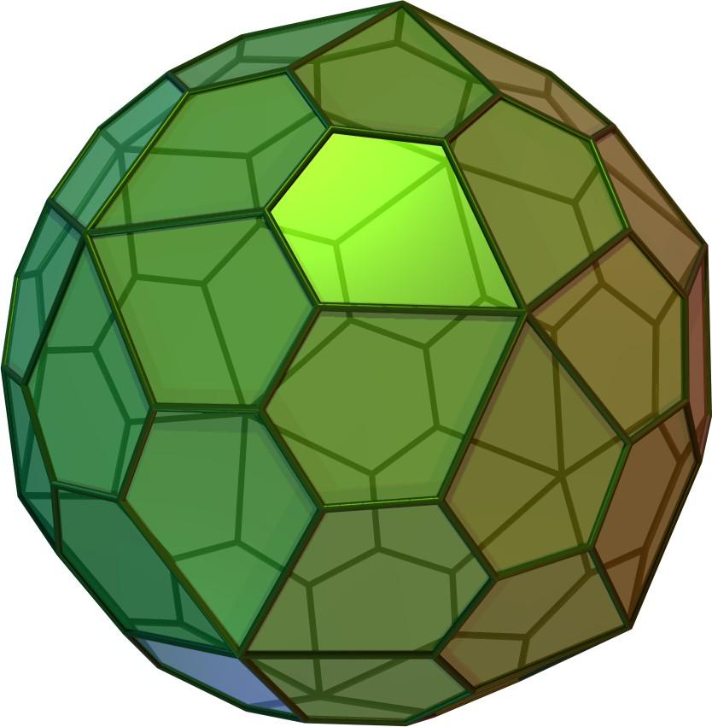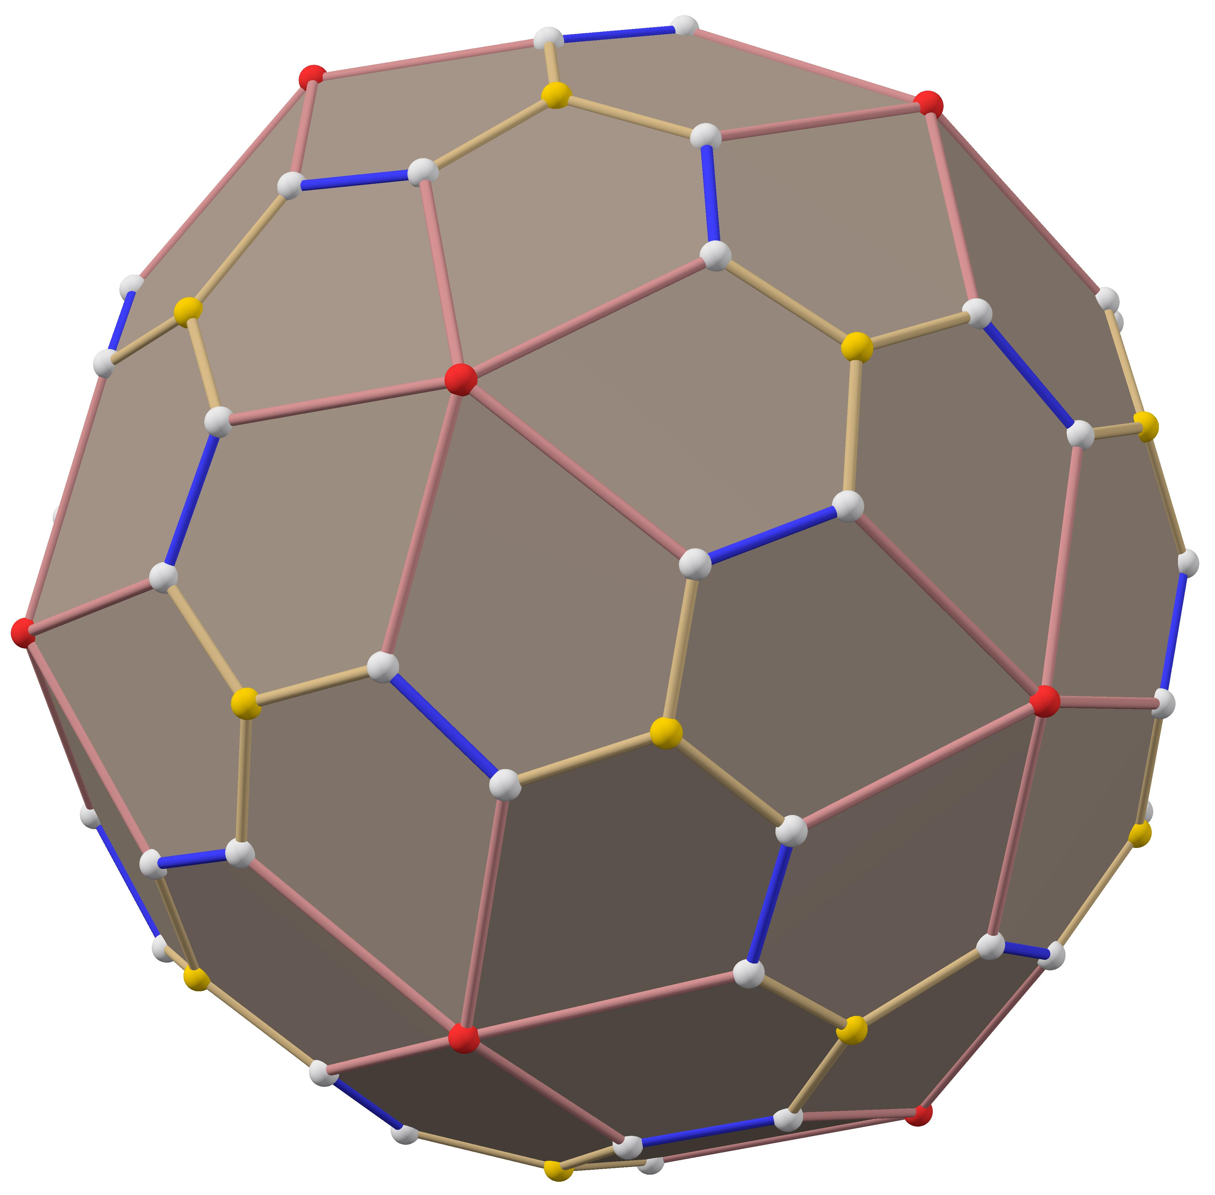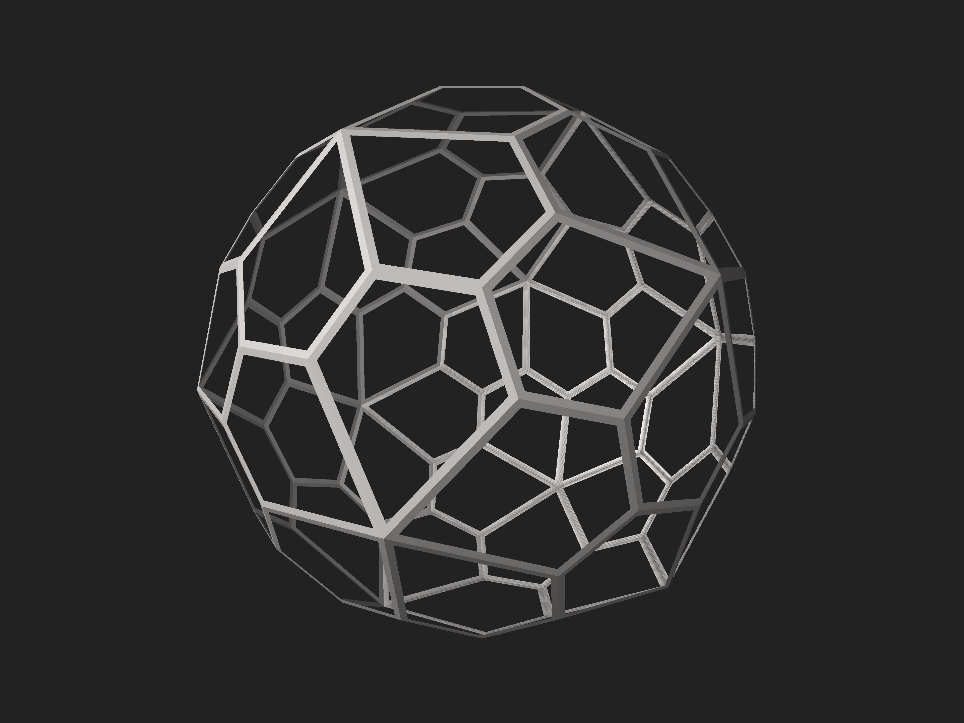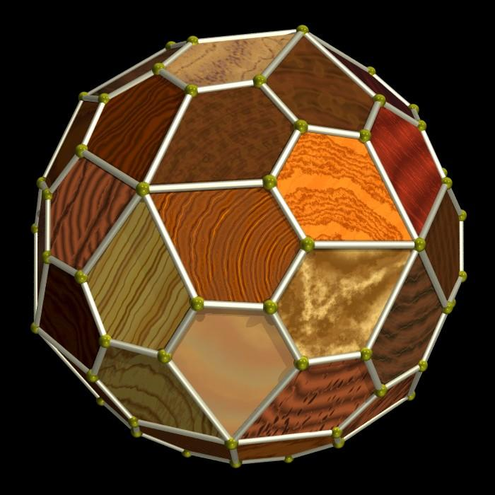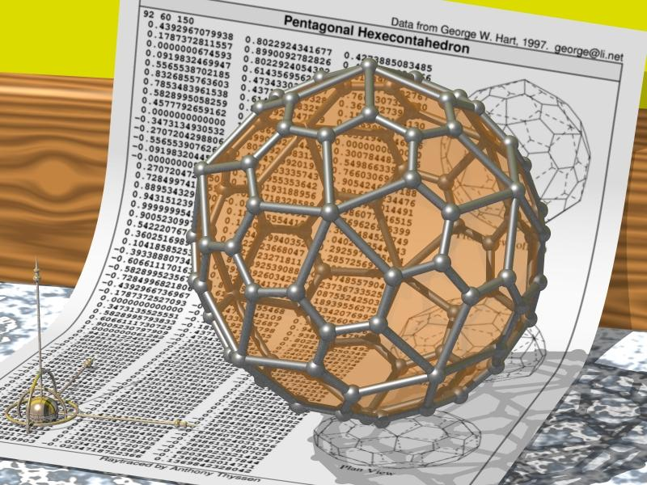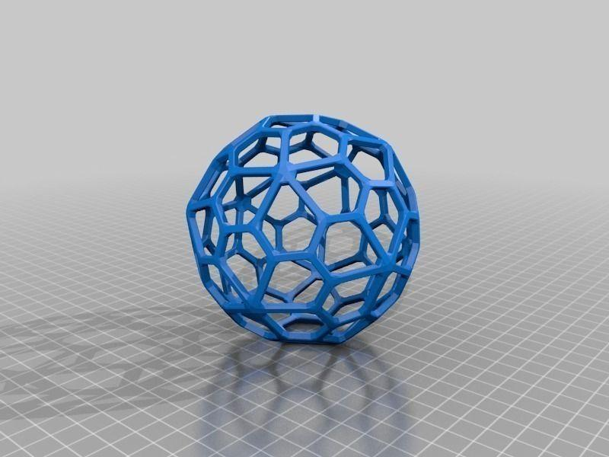

Simple Definition
# Source: AI Source: Provided by: [Data Path: Persons Table -> ID Column: 1, Name_En Column: Motasem Essam] -> From: [ChatGPT] on [7/25/2026]
The Pentagonal Hexecontahedron is a three-dimensional solid made of 60 identical pentagons.
Unlike a regular pentagon, each face has sides of two different lengths and angles of two different measures. The solid has a distinctive twisted appearance because it is related to the chiral Snub Dodecahedron.

Geometric Structure
# Source: AI Source: Provided by: [Data Path: Persons Table -> ID Column: 1, Name_En Column: Motasem Essam] -> From: [ChatGPT] on [7/25/2026]
Its main geometric features are:
- 60 faces: all congruent irregular pentagons.
- 150 edges: divided into two groups of different lengths.
- 92 vertices: divided into two groups according to the number of edges meeting at each vertex.
- Convex shape: all faces enclose a solid without self-intersections.
- Chiral structure: it exists in two mirror-image forms.

Face Structure
# Source: AI Source: Provided by: [Data Path: Persons Table -> ID Column: 1, Name_En Column: Motasem Essam] -> From: [ChatGPT] on [7/25/2026]
The Pentagonal Hexecontahedron has 60 congruent irregular pentagonal faces.
Each pentagonal face contains:
- Three short edges.
- Two long edges.
- Four equal obtuse angles.
- One acute angle.
The approximate interior angles are:
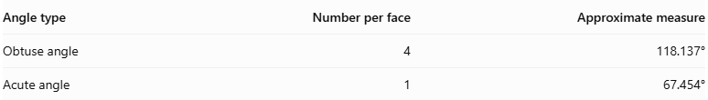
Angle type | Number per face | Approximate measure
Obtuse angle | 4 | 118.137°
Acute angle | 1 | 67.454°
The sum of the five interior angles is:
$$4({118.137}^{°})+{67.454}^{°}≈{540}^{°}$$
This is the required interior-angle sum of a pentagon:
$$(5-2)×{180}^{°}={540}^{°}$$
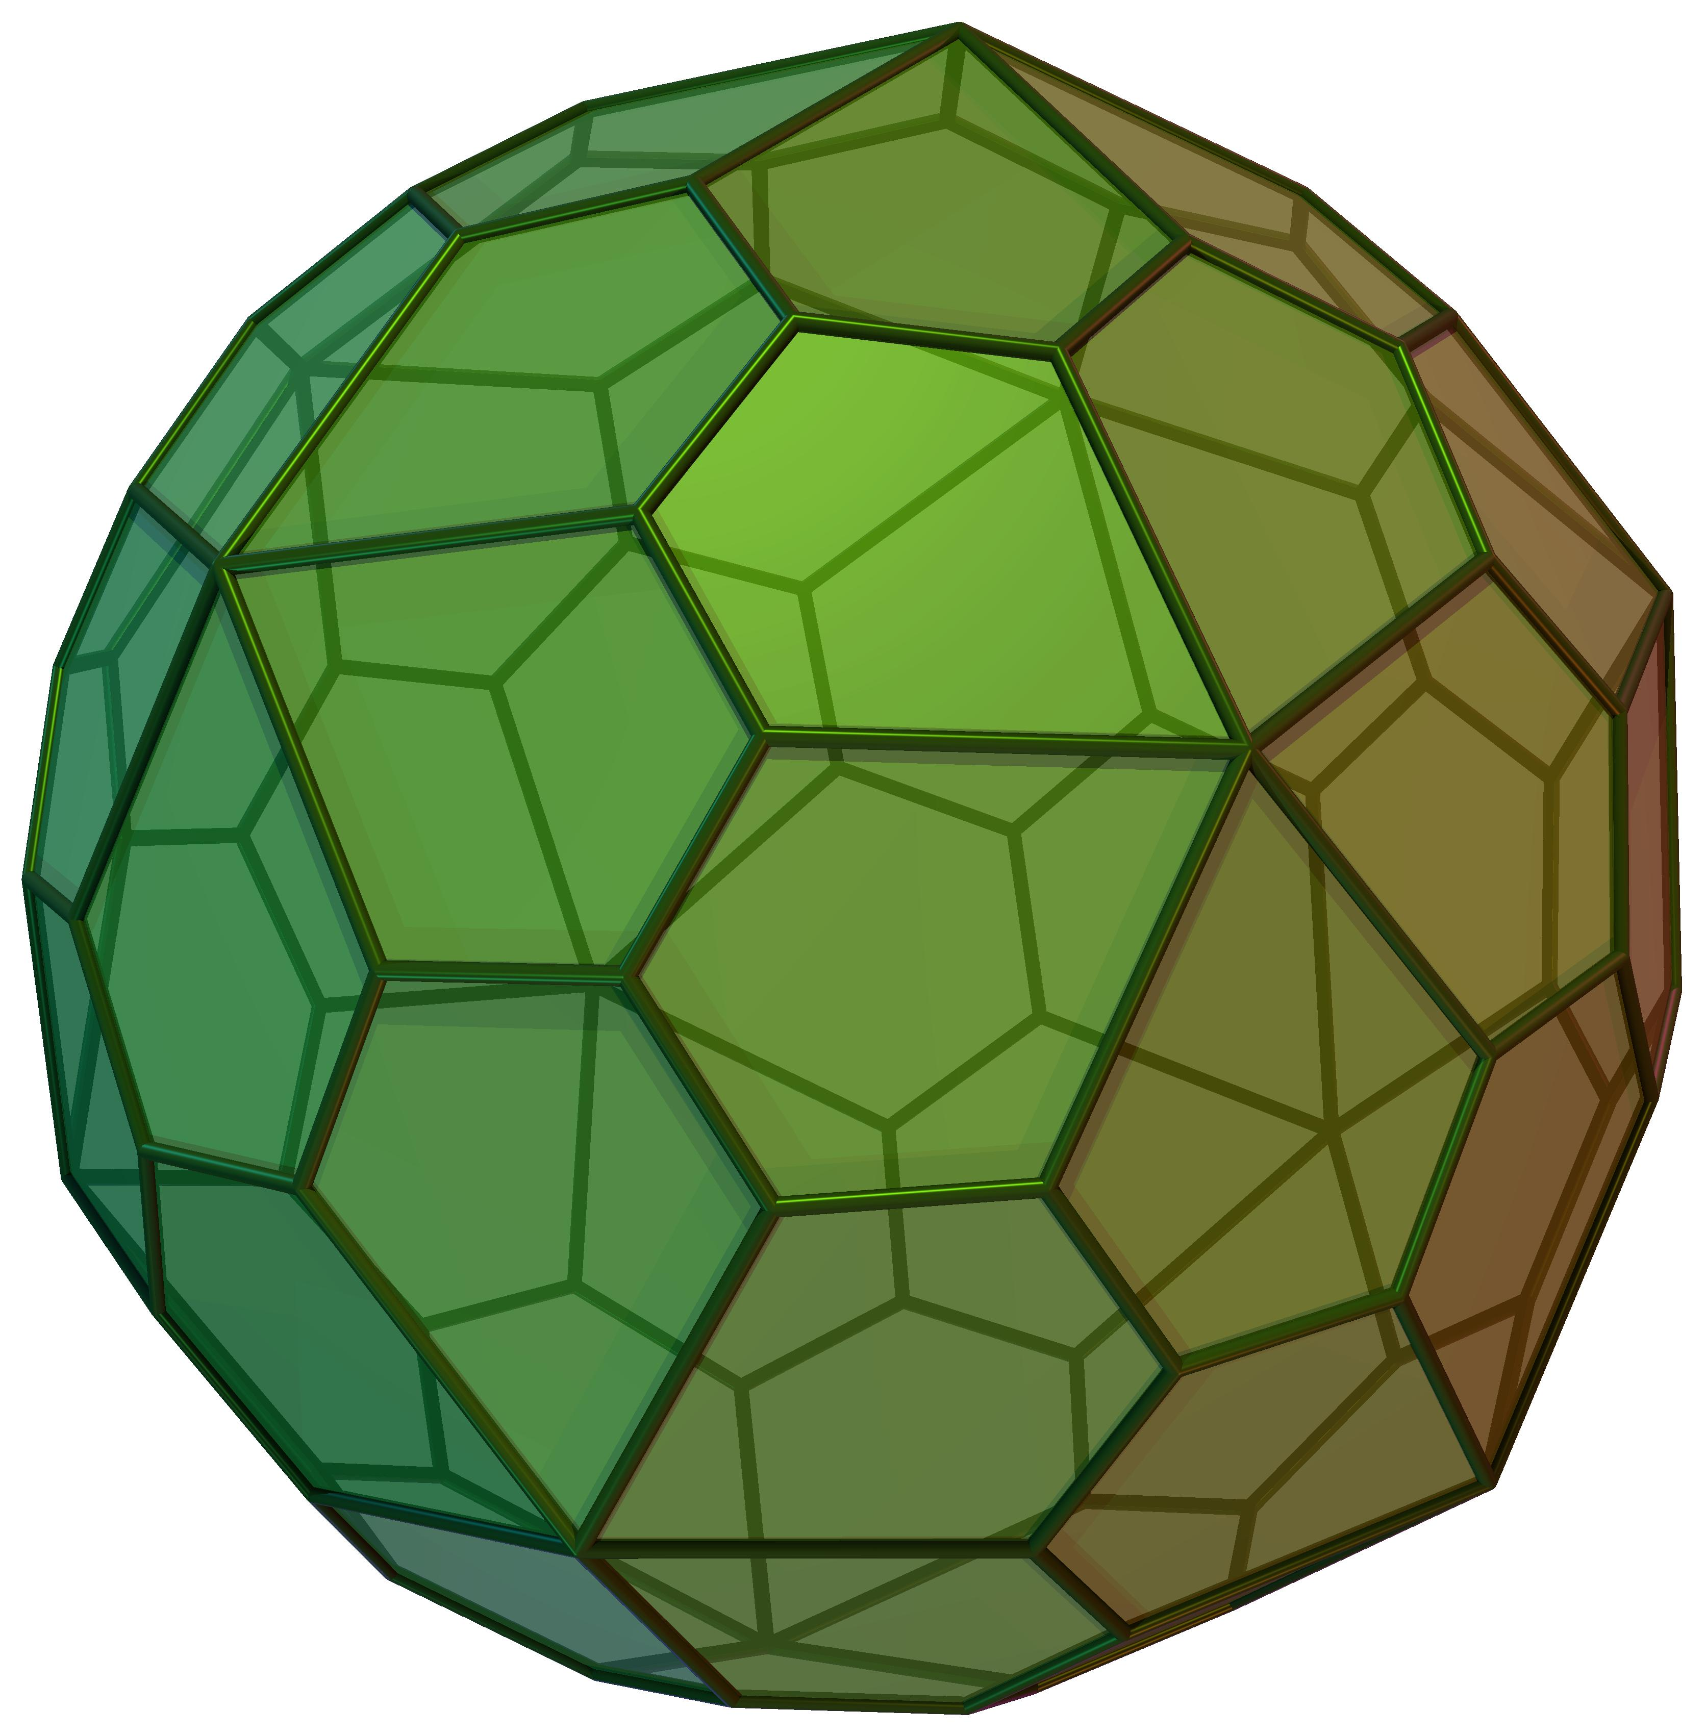

Edge Structure
# Source: AI Source: Provided by: [Data Path: Persons Table -> ID Column: 1, Name_En Column: Motasem Essam] -> From: [ChatGPT] on [7/25/2026]
The solid has 150 edges, divided into two groups:
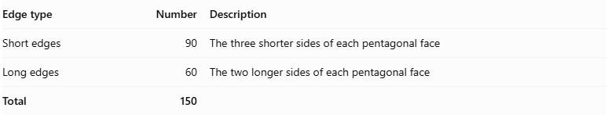
Edge type | Number | Description
Short edges | 90 | The three shorter sides of each pentagonal face
Long edges | 60 | The two longer sides of each pentagonal face
Total | 150
For the standard model whose dual Snub Dodecahedron has unit edge length:
- Short edge length: approximately 0.582900 units.
- Long edge length: approximately 1.019988 units.
The ratio of long edge to short edge is approximately:
$$\frac{1.019988}{0.582900}≈1.750$$
These measurements depend on the chosen scale.

Vertex Structure
# Source: AI Source: Provided by: [Data Path: Persons Table -> ID Column: 1, Name_En Column: Motasem Essam] -> From: [ChatGPT] on [7/25/2026]
The Pentagonal Hexecontahedron has 92 vertices, divided into two groups:
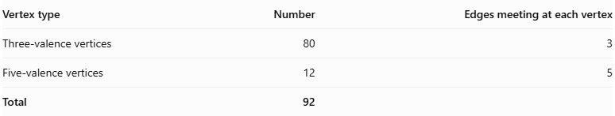
Vertex type | Number | Edges meeting at each vertex
Three-valence vertices | 80 | 3
Five-valence vertices | 12 | 5
Total | 92
- 80 three-valence vertices: three edges and three pentagonal faces meet at each vertex.
- 12 five-valence vertices: five edges and five pentagonal faces meet at each vertex.

Mathematical Properties
# Source: AI Source: Provided by: [Data Path: Persons Table -> ID Column: 1, Name_En Column: Motasem Essam] -> From: [ChatGPT] on [7/25/2026]
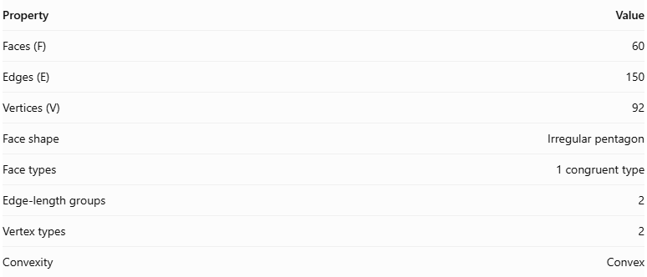
Property | Value
Faces (F) | 60
Edges (E) | 150
Vertices (V) | 92
Face shape | Irregular pentagon
Face types | 1 congruent type
Edge-length groups | 2
Vertex types | 2
Convexity | Convex
Euler's formula
For a convex polyhedron:
$$V-E+F=2$$
Substituting the values:
$$92-150+60=2$$
Therefore, the Pentagonal Hexecontahedron satisfies Euler's polyhedron formula.
Dihedral angle
All edges have the same dihedral angle:
$$\boxed{θ≈{153.179}^{°}}$$

Symmetry
# Source: AI Source: Provided by: [Data Path: Persons Table -> ID Column: 1, Name_En Column: Motasem Essam] -> From: [ChatGPT] on [7/25/2026]
The Pentagonal Hexecontahedron has chiral icosahedral symmetry, denoted by $I$.
Its symmetry characteristics include:
- Fivefold rotational axes.
- Threefold rotational axes.
- Twofold rotational axes.
- No reflection symmetry for the complete solid.
- No inversion symmetry.
It exists in two mirror-image forms:
- Dextro form: one handed arrangement.
- Laevo form: the opposite handed arrangement.
These two forms are mirror images but cannot be superimposed by rotation alone. This property is called chirality.
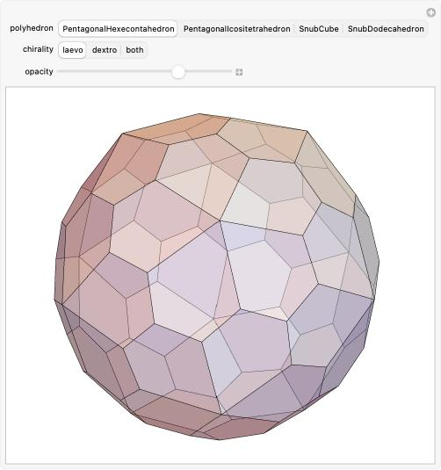

Surface Area and Volume
# Source: AI Source: Provided by: [Data Path: Persons Table -> ID Column: 1, Name_En Column: Motasem Essam] -> From: [ChatGPT] on [7/25/2026]
Surface area and volume depend on the scale of the solid.
For the standard Pentagonal Hexecontahedron whose dual Snub Dodecahedron has unit edge length:
Surface area
$$SA≈55.2805$$
Volume
$$V≈37.5884$$
These values are in square units and cubic units, respectively, under that specific normalization. If the solid is scaled by a factor $k$, its surface area scales by $k^{2}$, and its volume by $k^{3}$.

Relationship to Other Solids
# Source: AI Source: Provided by: [Data Path: Persons Table -> ID Column: 1, Name_En Column: Motasem Essam] -> From: [ChatGPT] on [7/25/2026]
The Pentagonal Hexecontahedron is the dual of the Snub Dodecahedron.
Pentagonal Hexecontahedron
- 60 faces
- 150 edges
- 92 vertices
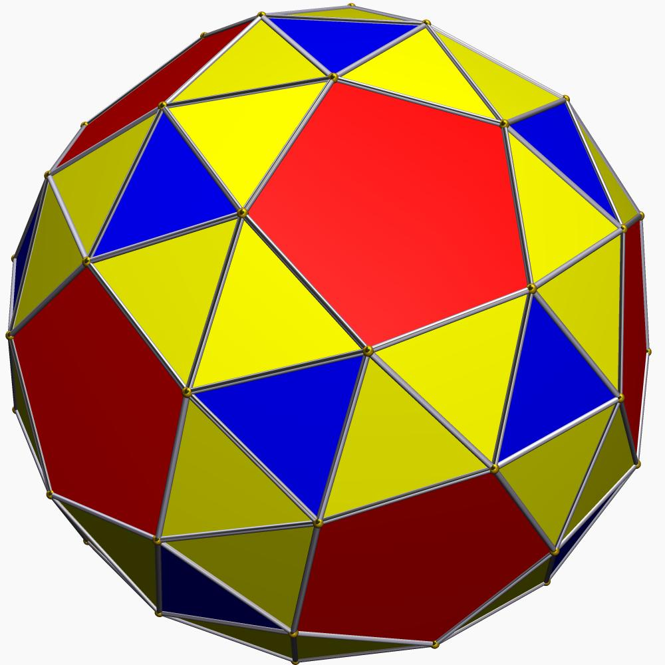
Snub Dodecahedron
- 92 faces
- 150 edges
- 60 vertices
In dual polyhedra:
- Each face corresponds to a vertex of the other solid.
- Each vertex corresponds to a face.
- Both solids have the same number of edges.
The Snub Dodecahedron has 12 pentagonal faces and 80 triangular faces, giving 92 faces in total.

Constructing a Pentagonal Hexecontahedron

Geometric Instruments Used
# Source: AI Source: Provided by: [Data Path: Persons Table -> ID Column: 1, Name_En Column: Motasem Essam] -> From: [ChatGPT] on [7/25/2026]
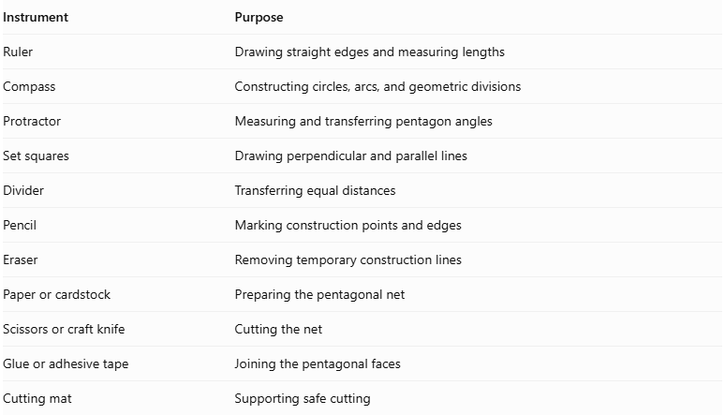
Instrument | Purpose
Ruler | Drawing straight edges and measuring lengths
Compass | Constructing circles, arcs, and geometric divisions
Protractor | Measuring and transferring pentagon angles
Set squares | Drawing perpendicular and parallel lines
Divider | Transferring equal distances
Pencil | Marking construction points and edges
Eraser | Removing temporary construction lines
Paper or cardstock | Preparing the pentagonal net
Scissors or craft knife | Cutting the net
Glue or adhesive tape | Joining the pentagonal faces
Cutting mat | Supporting safe cutting

Instrument-Based Construction Procedures

Method 1: Construction Using a Pentagonal Net
# Source: AI Source: Provided by: [Data Path: Persons Table -> ID Column: 1, Name_En Column: Motasem Essam] -> From: [ChatGPT] on [7/25/2026]
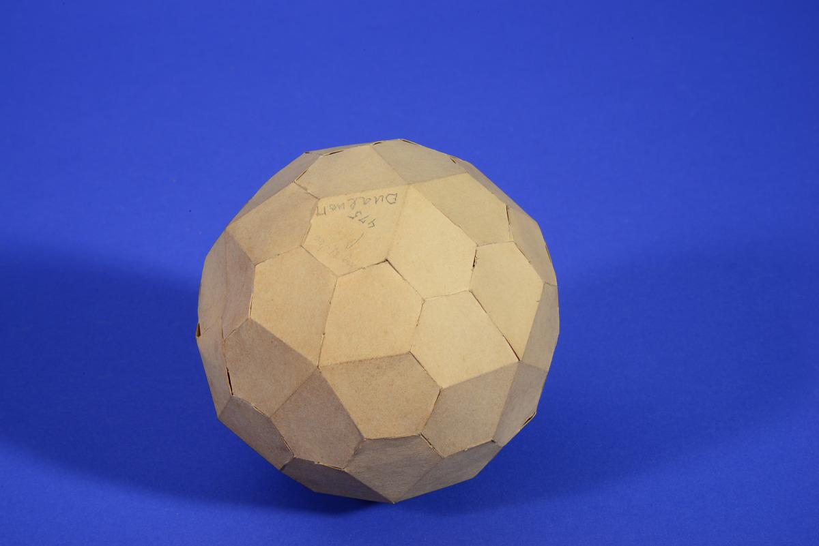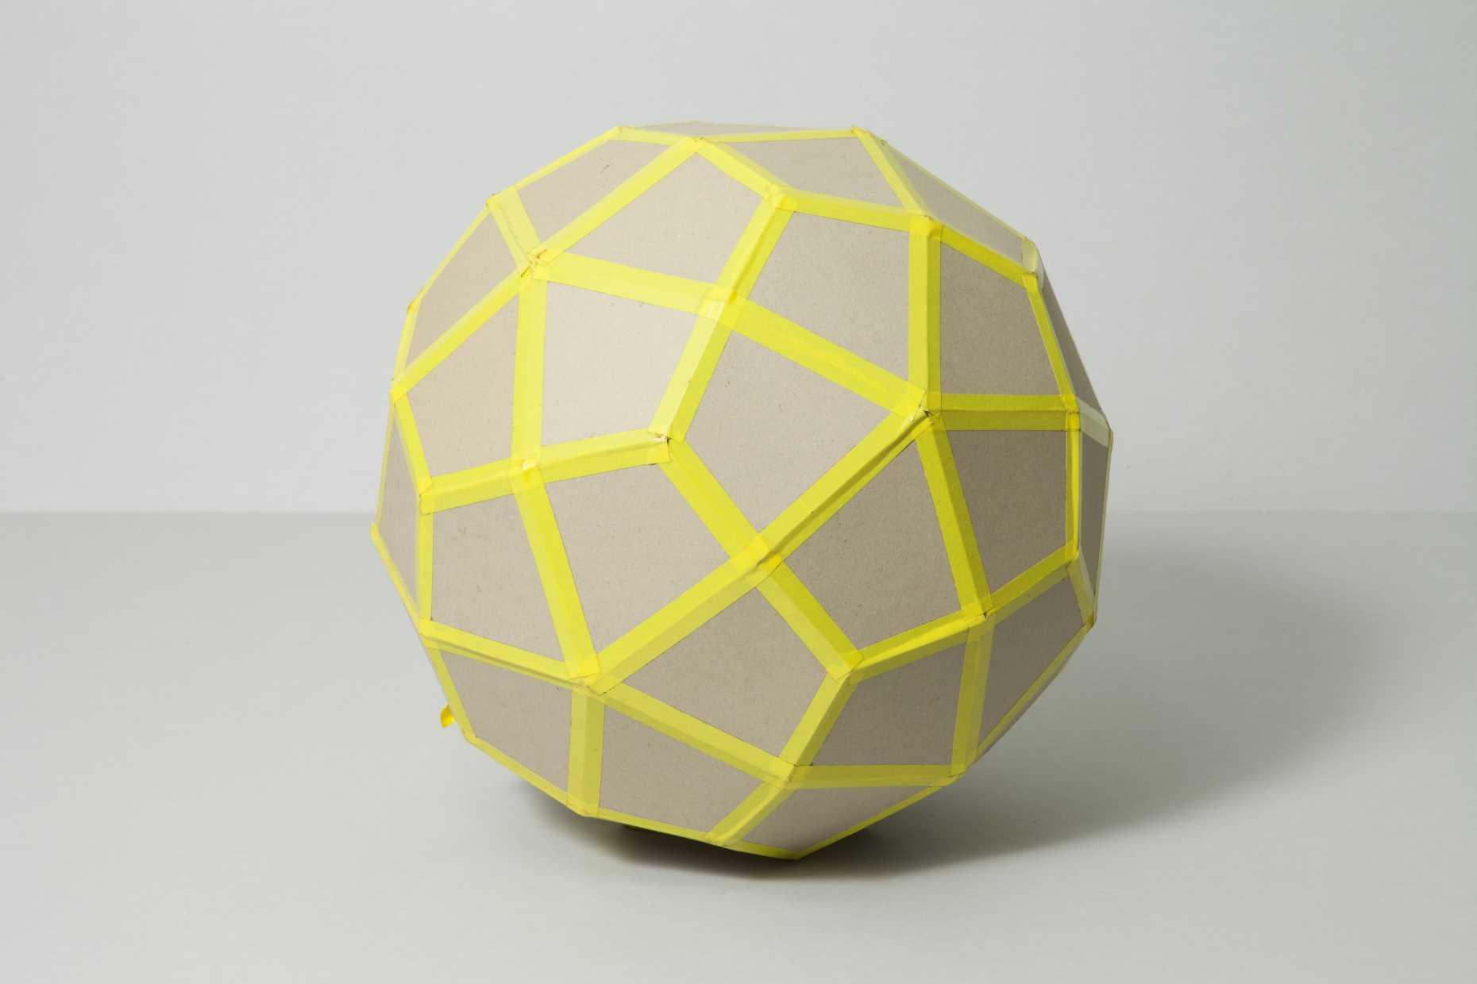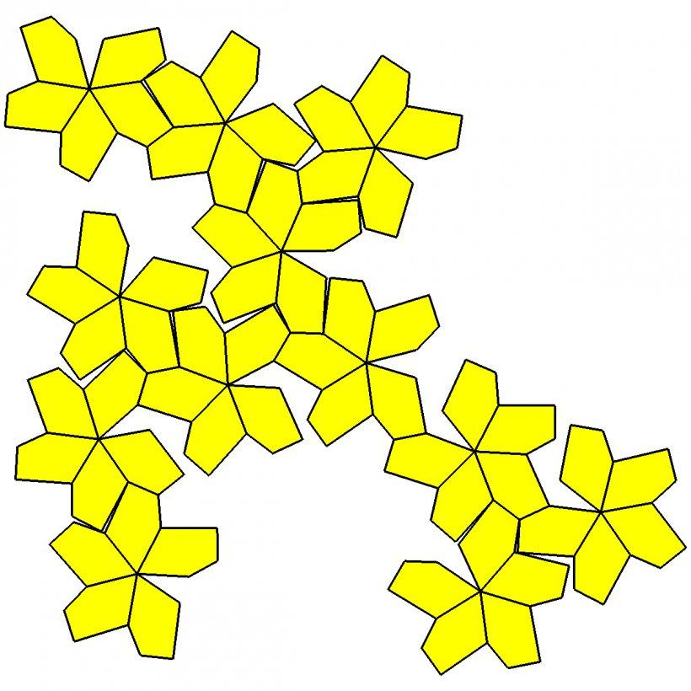
- Determine the face dimensions: Establish the short-edge and long-edge lengths using the standard edge-length ratio.
- Construct the pentagonal face: Use a ruler, compass, and protractor to draw an irregular pentagon with three short edges and two long edges.
- Transfer the face pattern: Reproduce the same pentagonal dimensions and angles for all 60 faces.
- Arrange the net: Position the pentagons according to a valid unfolding of the Pentagonal Hexecontahedron.
- Mark the joining edges: Identify corresponding edges that will meet during assembly.
- Add joining tabs: Include tabs along selected external edges.
- Cut out the net: Carefully cut around its external boundary.
- Fold the faces: Fold along the designated joining edges.
- Join the pentagons: Attach matching edges using glue or adhesive tape.
- Complete the solid: Check that all 60 pentagonal faces meet correctly and that the model closes without gaps.

Method 2: Construction Through the Dual of a Snub Dodecahedron
# Source: AI Source: Provided by: [Data Path: Persons Table -> ID Column: 1, Name_En Column: Motasem Essam] -> From: [ChatGPT] on [7/25/2026]
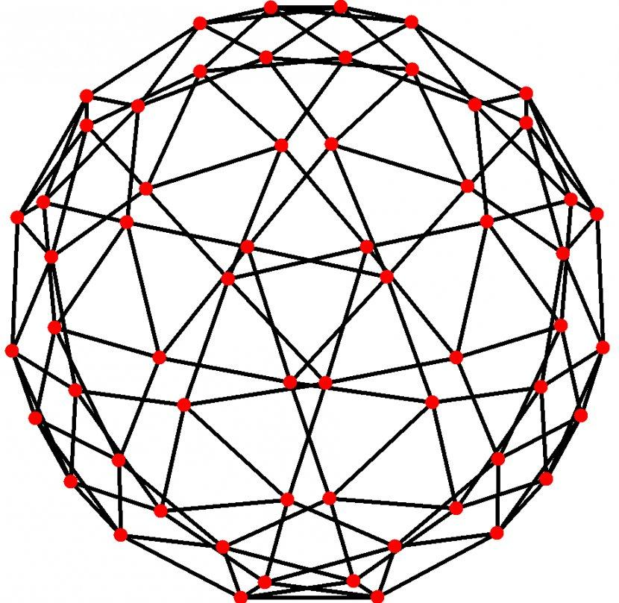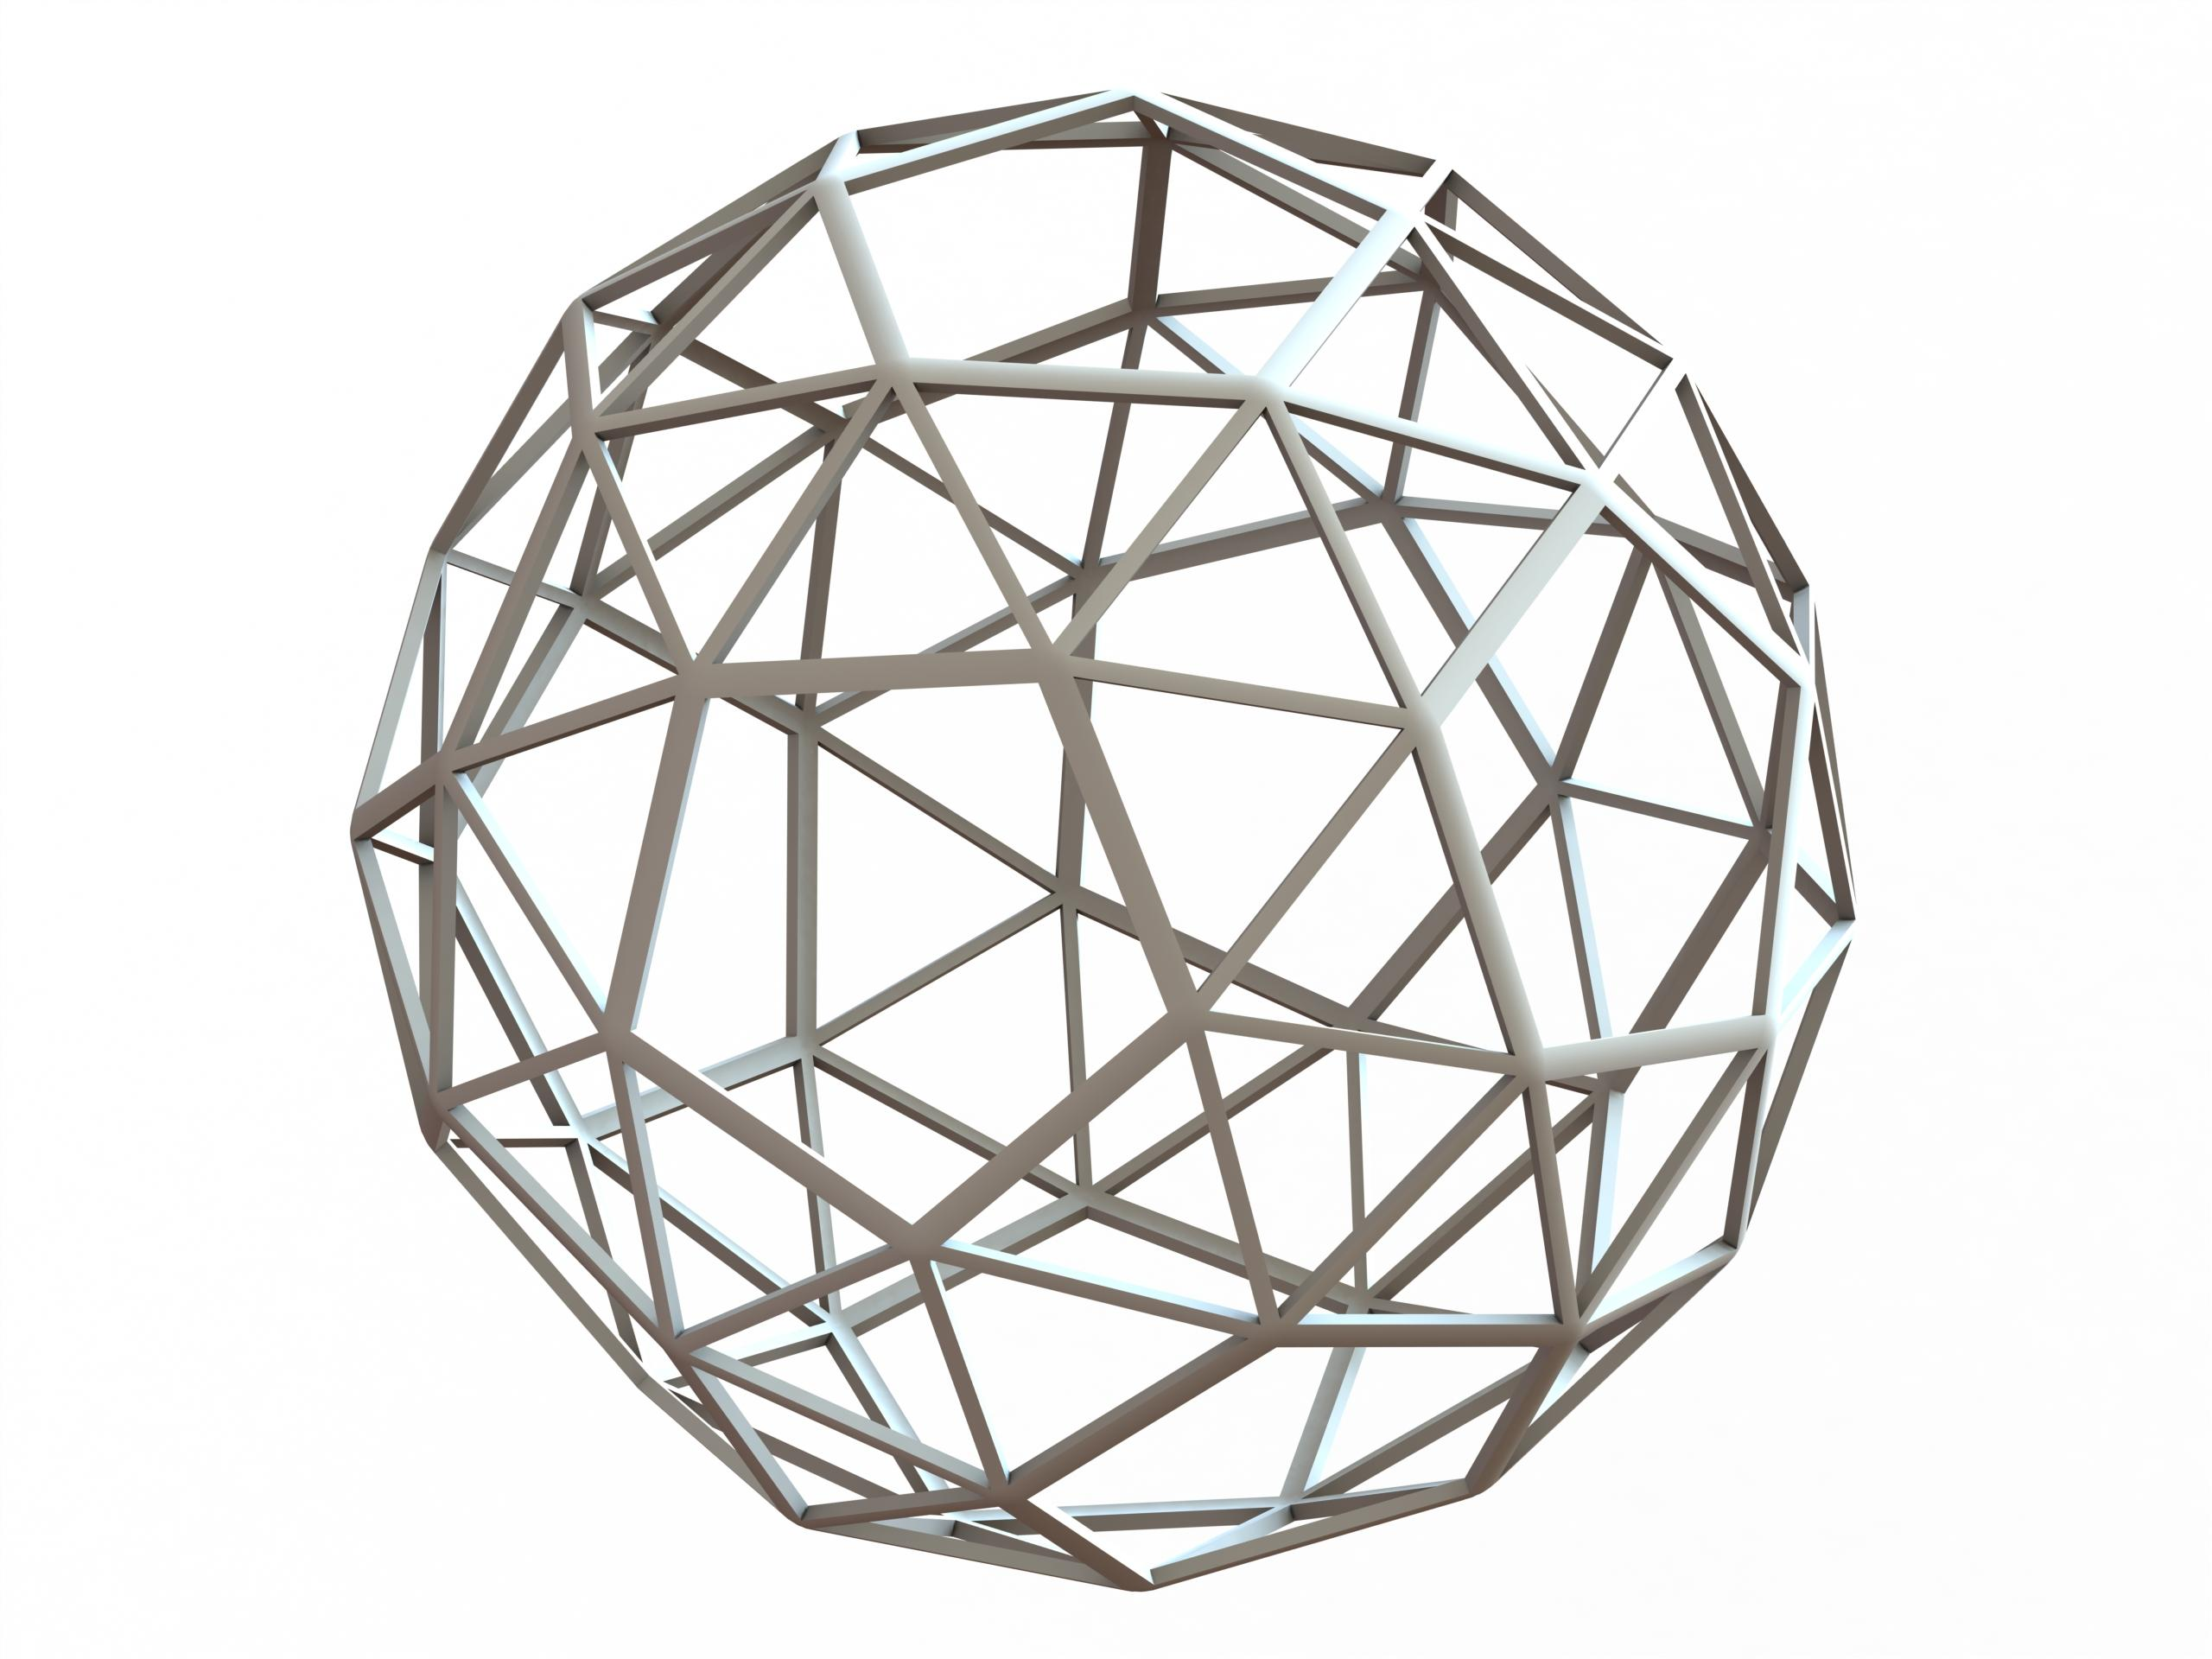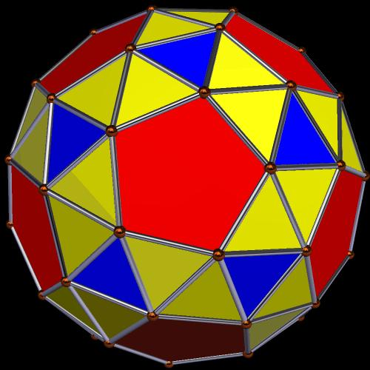
This method constructs the Pentagonal Hexecontahedron through the geometric duality relationship with the Snub Dodecahedron.
- Construct a Snub Dodecahedron: Establish its 12 pentagonal faces and 80 triangular faces using geometric drawing instruments.
- Identify the original vertices: Locate its 60 vertices and determine the faces meeting at each vertex.
- Construct the face planes: Identify the planes of the 12 pentagons and 80 triangles.
- Determine the dual vertices: Construct one dual vertex corresponding to each of the 92 original faces.
- Establish the dual connections: Connect dual vertices corresponding to adjacent faces of the Snub Dodecahedron.
- Construct the pentagonal faces: Each original vertex has five surrounding faces; their corresponding dual vertices form one pentagonal face.
- Apply the correct dual scaling: Use a polar-dual construction or reciprocal-plane distances to obtain the standard dual. Ordinary face centers alone do not necessarily produce the correct dual vertices.
- Preserve the handedness: Maintain the chosen right-handed or left-handed orientation throughout the construction.
- Verify the solid: Confirm that the completed polyhedron has 60 pentagonal faces, 150 edges, and 92 vertices.

Key Points
# Source: AI Source: Provided by: [Data Path: Persons Table -> ID Column: 1, Name_En Column: Motasem Essam] -> From: [ChatGPT] on [7/25/2026]
- The Pentagonal Hexecontahedron is one of the 13 Catalan solids.
- It has 60 congruent irregular pentagonal faces.
- It has 150 edges and 92 vertices.
- Each pentagonal face has three short edges and two long edges.
- It has two vertex types: 80 vertices of valence 3 and 12 vertices of valence 5.
- It is the dual of the Snub Dodecahedron.
- It has chiral icosahedral symmetry $I$.
- It exists in two mirror-image forms: dextro and laevo.
- It is a convex polyhedron.

Conclusion
# Source: AI Source: Provided by: [Data Path: Persons Table -> ID Column: 1, Name_En Column: Motasem Essam] -> From: [ChatGPT] on [7/25/2026]
The Pentagonal Hexecontahedron is a distinctive Catalan solid characterized by its 60 irregular pentagonal faces, two different edge lengths, and two types of vertices. Its chirality and dual relationship with the Snub Dodecahedron make it an important example of symmetry and polyhedral duality in solid geometry.

References
# Source: AI Source: Provided by: [Data Path: Persons Table -> ID Column: 1, Name_En Column: Motasem Essam] -> From: [ChatGPT] on [7/25/2026]
- Wolfram MathWorld – Pentagonal Hexecontahedron.
- David McCooey – Pentagonal Hexecontahedron.
- QFBox – The Catalan Solids.
- Software3D – Pentagonal Hexecontahedron.
- Pentagonal Hexecontahedron – Geometric Properties.

